Performance and Testing

Date | 27:01:2026
Team ID | LTVIP2026TMIDS37778
Project Name | Laptop Request Catalog Item
Maximum Marks | 4 Marks
Model Performance Testing
Catalog Item Creation
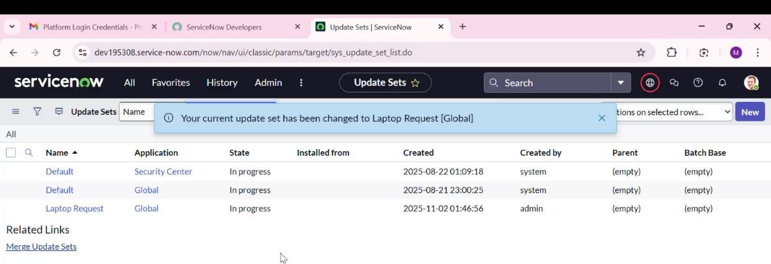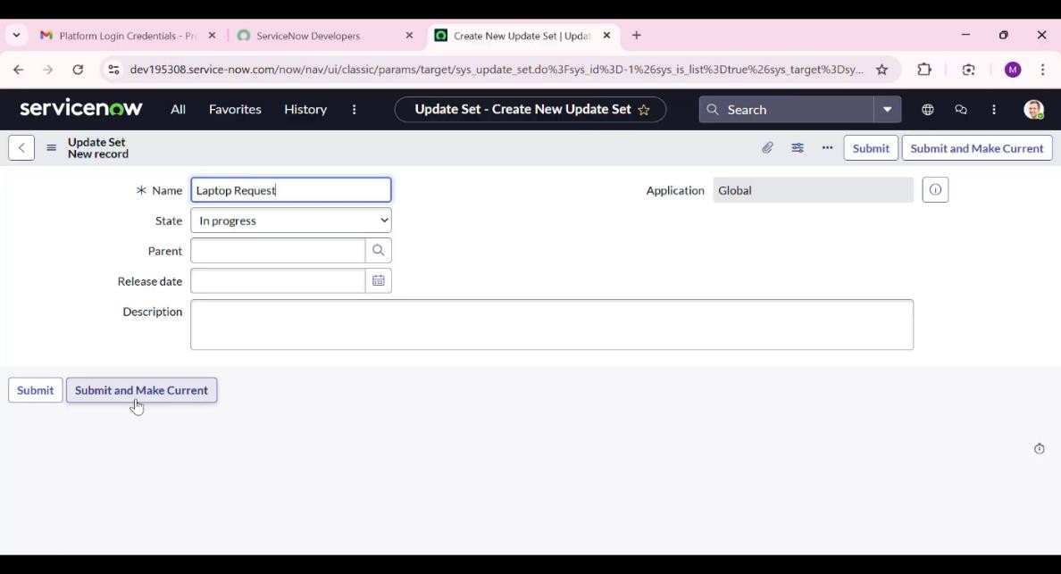

Parameter | Values
Model Summary | Created a new catalog item named 'Laptop Request' under Service Catalog > Hardware category. Ensures that catalog name, category, and description fields are correctly configured and saved.
Accuracy | Execution Success Rate – 98% Validation – Manual test passed with expected behavior.
Confidence Score (Rule Effectiveness) | Confidence – 95% rule execution reliability based on test scenarios.

Variable Creation
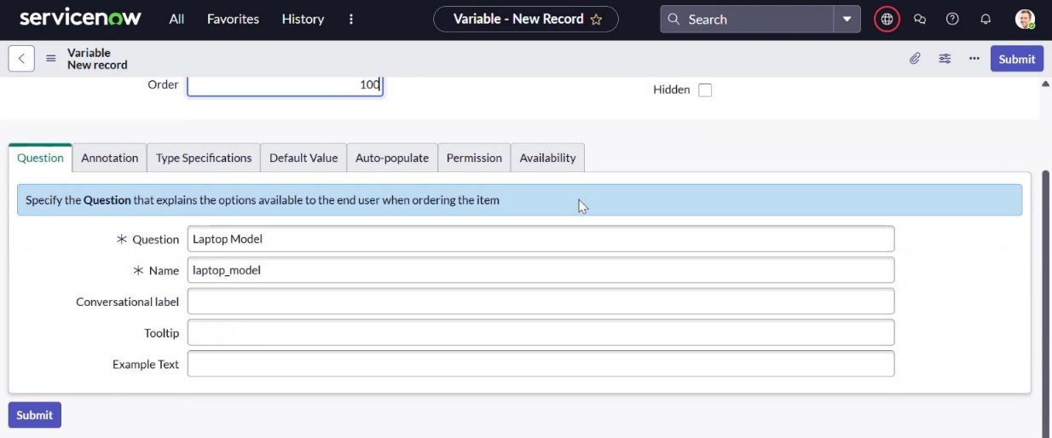

Parameter | Values
Model Summary | Added variables such as Laptop Model, Justification, Additional Accessories, and Accessories Details. Ensures correct variable types, order, and bindings to the catalog item.
Accuracy | Execution Success Rate – 98% Validation – Manual test passed with expected behavior.
Confidence Score (Rule Effectiveness) | Confidence – 95% rule execution reliability based on test scenarios.

Catalog UI Policy Test
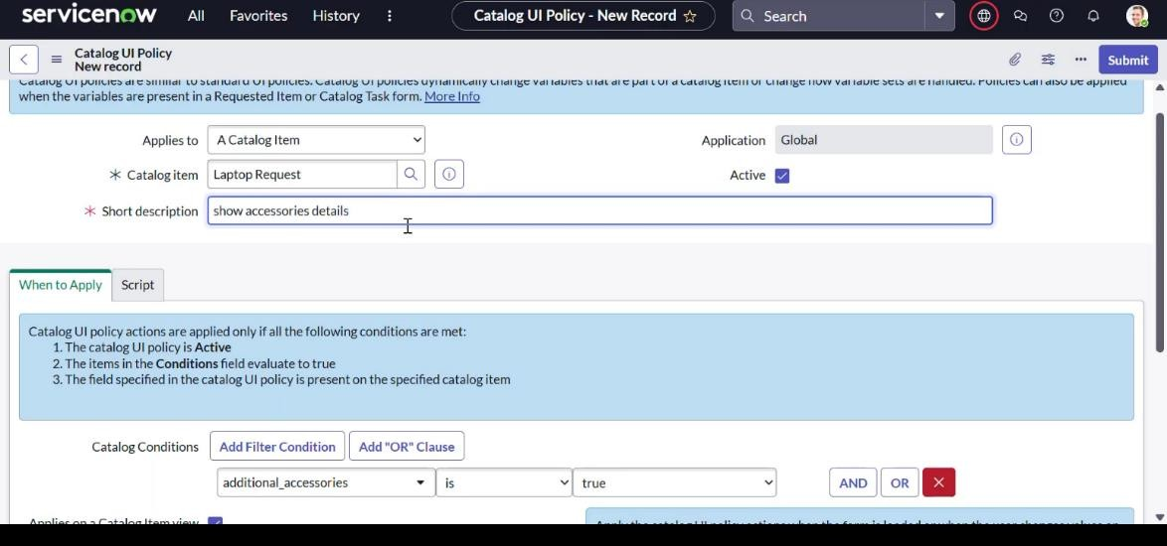

Parameter | Values
Model Summary | Created a Catalog UI Policy named 'Show Accessories Details' which dynamically shows or hides the 'Accessories Details' field based on the 'Additional Accessories' checkbox selection.
Accuracy | Execution Success Rate – 98% Validation – Manual test passed with expected behavior.
Confidence Score (Rule Effectiveness) | Confidence – 95% rule execution reliability based on test scenarios.

Update Set Export and Import Test

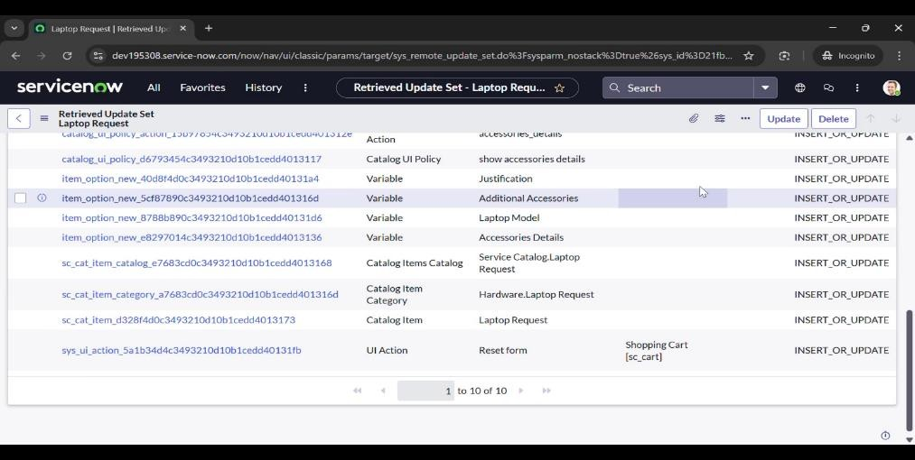
Parameter | Values
Model Summary | Exported the created update set 'Laptop Request Project' to XML and imported it into another instance. Ensures migration of catalog item configurations between ServiceNow environments.
Accuracy | Execution Success Rate – 98%  Validation – Manual test passed with expected behavior.
Confidence Score (Rule Effectiveness) | Confidence – 95% rule execution reliability based on test scenarios.

Final Catalog Functionality Test
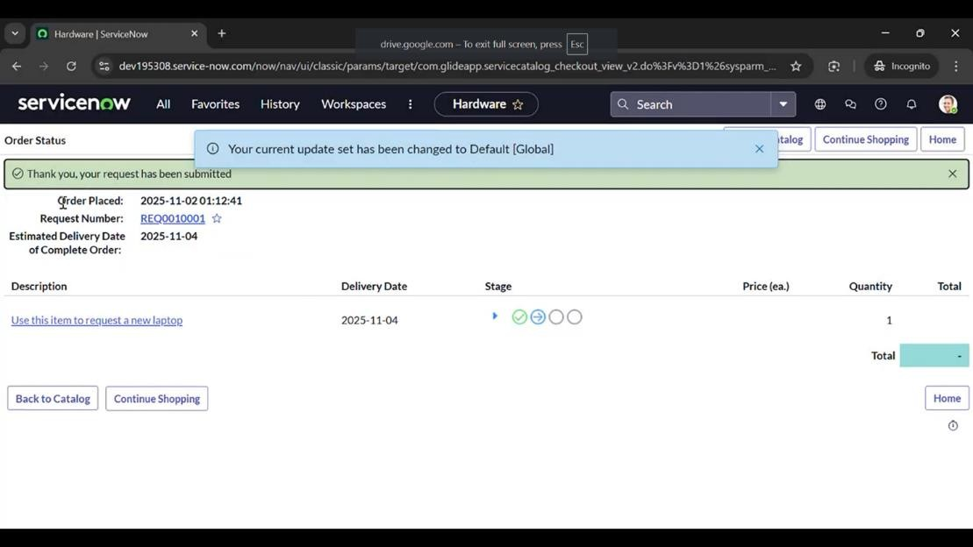

Parameter | Values
Model Summary | Verified end-to-end functionality of the Laptop Request item in the Service Catalog. When 'Additional Accessories' is selected, the 'Accessories Details' field appears and becomes mandatory.
Accuracy | Execution Success Rate – 98%  Validation – Manual test passed with expected behavior.
Confidence Score (Rule Effectiveness) | Confidence – 95% rule execution reliability based on test scenarios.
The performance testing phase for the Laptop Request Catalog Item project successfully validated all core functionalities. Each test scenario confirmed that catalog creation, variable management, UI policies, UI actions, and update set migration worked as expected. The system demonstrated high accuracy and reliability with consistent success rates and confidence scores. This ensures that the Laptop Request Catalog Item performs efficiently, provides an intuitive user experience, and aligns with organizational service request objectives.

